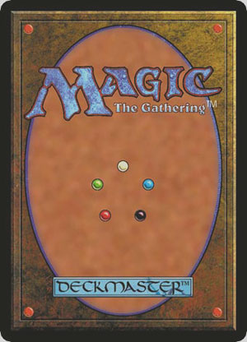
Magic

Part I Due 3/18 before class
Final Due 3/20 before class

The goal of this assignment is to gain an understanding of the collectible card game genre, and the game design principles used to create Magic: the Gathering.

Part I
Play the demo version of Magic: the Gathering. You can download it here:
http://www.wizards.com/magic/tcg/newtomagic.aspx?x=mtg/tcg/newtomagic/learntoplay

Click the Download Demo link, install it (on a Windows PC) and play. If you don’t have a Windows PC, try to find someone who does. If you can’t play the demo, you can instead read the rules by clicking the Download Rules PDF link. The demo is a better way to learn.

If you already know the rules of Magic, you can skip this part, or browse through the official tournament rules of Magic here:
http://www.wizards.com/magic/comprules/MagicCompRules_20110930.txt

Complete this part before coming to class. We will be playing Magic in class, so please come prepared with some knowledge of how to play.

Final
After reading the articles (and before the deadline), send an e-mail to Ira with your thoughts on the articles and the overall assignment. These articles are written by Mark Rosewater, the lead game designer of Magic:

http://www.wizards.com/Magic/Magazine/Article.aspx?x=mtg/daily/mm/159
http://www.wizards.com/Magic/Magazine/Article.aspx?x=mtg/daily/mm/160
http://www.wizards.com/Magic/Magazine/Article.aspx?x=mtg/daily/mm/163
http://www.wizards.com/Magic/Magazine/Article.aspx?x=mtg/daily/mm/164

These are optional additional readings:
http://www.wizards.com/Magic/Magazine/Article.aspx?x=mtg/daily/mm/161
http://www.wizards.com/Magic/Magazine/Article.aspx?x=mtg/daily/mm/162
http://www.wizards.com/Magic/Magazine/Article.aspx?x=mtg/daily/mm/177
http://www.wizards.com/Magic/Magazine/Article.aspx?x=mtg/daily/mm/178

He writes articles every week, and they’re usually pretty good. Even more reading here, in case you’re interested. It’s all optional:
http://www.wizards.com/Magic/Magazine/Archive.aspx?author=Mark%20Rosewater

Original assignment designed by Professor Ira Fay.

